Code Components
- Frontend
- ReactJS – (Version 19.2.3)
  - Redux Toolkit
  - HTML, CSS, JavaScript
  - Local Storage (Cart Persistence)
- Backend
- .NET Core Web API – (Version .NET core 8)
  - Swagger for API documentation
  - Dapper for micro ORM
  - Redis (Caching) for faster search result
  - Docker for Redis
- DB
- Microsoft SQL Server 2019

Deployment Guide for running the solutions from Docker
- Create a folder for “SmartCartDocker”
- Place the all the code projects in that folder
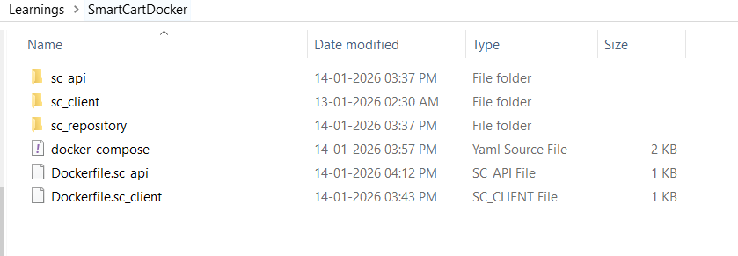
- Create docker file for API
- Create docker file for UI
- Create DockerFile for Redis
- Create the compose YML file
- The solution is pointing to the local DB now. The DB location can be changed in compose YML file for the ConnectionStrings.
Attachments

